Hi Henry,

Below are the locations in HPM_WMS, please note.

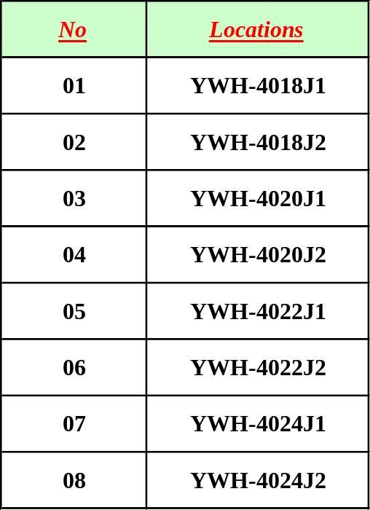

Lunch, no problem,ok.

Best Regards
Edwin Ong
Inventory Controller
BAX Global Pte. Ltd.
452 Alexandra Road
Hewlett Packard Building
Singapore 119961

+65 98638336 Mobile
+65 63741958 Fax

 | Henry Tjan / SIN  IT Account Manager; Logistics; Singapore  09/06/2003 04:42 PM | To: Edwin Ong/PACIFIC/BAX@BAX  cc: Denz Camacho/PACIFIC/BAX@BAX, WeiYan Wu/PACIFIC/BAX@BAX, Clarito Ablanque/PACIFIC/BAX@BAX, ChristopherYK Lim/PACIFIC/BAX@BAX  Subject: Re: HPM_WMS Allocation Logic

Hi Edwin,

As discussed, please provide the Alpha-ywh locations. So that Denz can start the development.
If you can provide by today, we will complete the development this Friday.
Remember to put your request in ASR. If you don't know how, then I'll help you to enter (remember to buy lunch for me, ok).

Regards,
HT
----- Forwarded by Henry Tjan/PACIFIC/BAX on 09/06/2003 04:40 PM -----

 | Henry Tjan / SIN  IT Account Manager; Logistics; Singapore  26/05/2003 12:03 PM | To: Edwin Ong/PACIFIC/BAX@BAX  cc: WeiYan Wu/PACIFIC/BAX@BAX, Clarito Ablanque/PACIFIC/BAX@BAX, Denz Camacho/PACIFIC/BAX@BAX  Subject: Re: HPM_WMS Allocation Logic

Hi Edwin,

Have checked with Denz & Clarito already. It is possible to change. Not to complex as long as only one dedicated location (Alpha-ywh). Hopefully, you won't add another location in the future.
We will treat Alpha-ywh as HOI location as well.

What will be affected is:
- For Normal PullKit, (2 days needed for develop and test)
The movement of good during Pick, it will move the stocks from Alpha-ywh to Bank Location.
No changes to the stock out report, it will still show HOI (HOI stocks & Alpha-ywh) & SOI.

- For Optional Pullkit, (2 days needed for develop and test)
The allocation logic will be changed, it will allocate from Alpha-ywh --> HOI --> Conversion.
No changes to the stock out report, it will still show HOI (HOI stocks & Alpha-ywh) & SOI.

There is one process affected also such as COI files that Maxcim send to BAX for daily matching. The file contains sku, issuing stores, and qty. Currently, we never use this process. So there is no changes. Just keep in mind.

Please let us know whether the understanding as above correct.

We will start the development on 2 June 2003. Is the time OK?? we've a lot of things to do this week.
Please make sure to enter your request in ASR, if you don't know how then check with Clarito.

Rgds,
HT

 | Edwin Ong / SIN  Inventory Controller; Logistics; Singapore  24/05/2003 08:36 AM | To: WeiYan Wu/PACIFIC/BAX@BAX, Henry Tjan/PACIFIC/BAX@BAX  cc:  Subject: HPM_WMS Allocation Logic

Hi Weiyan & Henry,

Need your help to further improve on the HPM_WMS allocation logic. Currently, our HPM_WMS allocation is that system will look for MWH (Direct HOI) that will follow by M2W (SOI conversion to HOI). But now the issue is that we are not following that FIFO rules as all the production returns will have to re-create a new ASN which means a new lot will be assigned for the ASN. I have already checked with HP as they have agreed to give us a new store acct in MAXCIM just for the production retuns under YWH. So, I am proposing if I ask the Ops to put all the production retuns under an assigned location (eg: Alpha-YWH) in WMS, can the system helps by first search for the materials under that locations first before going to HOI that SOI.

Hope you can advise on how many days you need to develop this new changes, thanks.

Best Regards
Edwin Ong
Inventory Controller
BAX Global Pte. Ltd.
452 Alexandra Road
Hewlett Packard Building
Singapore 119961

+65 98638336 Mobile
+65 63741958 Fax

